**DAILY ONLINE ACTIVITIES SUMMARY**

|  |  |  |  |  |  |  |  |  |
| --- | --- | --- | --- | --- | --- | --- | --- | --- |
| **Date:** | **06/06/2020** | | | | | **Name:** | **Lavanya D M** | |
| **Sem & Sec** | **4th & ‘A’** | | | | | **USN:** | **4al18cs041** | |
| **Online Test Summary** | | | | | | | | |
| **Subject** | | **Data Communication** | | | | | | |
| **Max. Marks** | | **30** | | **Score** | | | **26** | |
| **Certification Course Summary** | | | | | | | | |
| **Course** | **Puzzle game making** | | | | | | | |
| **Certificate Provider** | | | **Bitdegree** | | **Duration** | | | **2 days** |
| **Coding Challenges** | | | | | | | | |
| **Problem Statement:1)** Write a program in C to rotate an array by N positions.  **2)** Write a Java Program to find the second-highest number in an array.  **3)**java program to sorting | | | | | | | | |
| **Status:complied** | | | | | | | | |
| **Uploaded the report in Github** | | | | | **yes** | | | |
| **If yes Repository name** | | | | | <https://github.com/lavanyamurthi/lockdown-coding> | | | |
| **Uploaded the report in slack** | | | | | **yes** | | | |

Online Test Details: (Attach the snapshot and briefly write the report for the same)

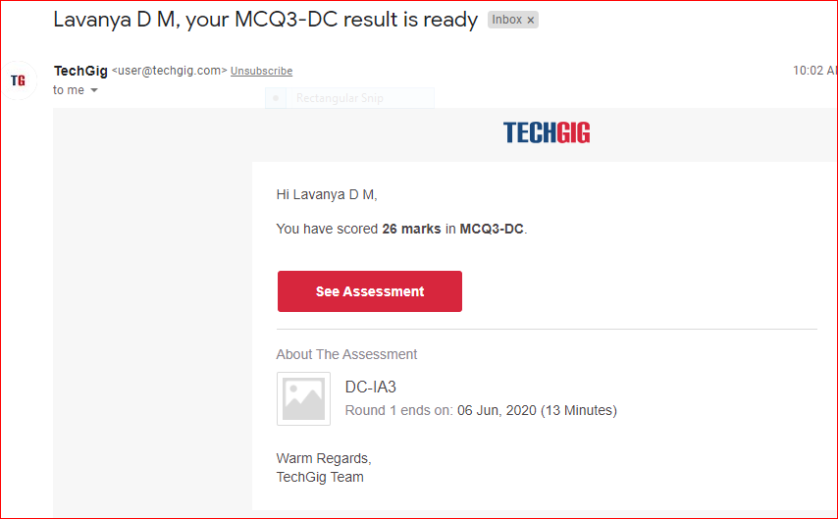

Certification Course Details: (Attach the snapshot and briefly write the report for the same)



Github link <https://github.com/lavanyamurthi/lockdown-certificate>

Coding Challenges Details: (Attach the snapshot and briefly write the report for the same)

Problem 1: Write a program in C to rotate an array by N positions.

**Expected Output :**  
**The given array is :** 0 3 6 9 12 14 18 20 22 25 27  
Enter the Position N from where you want to rotate: 4  
From 4th position the values of the array are : 12 14 18 20 22 25 27  
Before 4th position the values of the array are : 0 3 6 9  
After rotating from 4th position the array is:  
12 14 18 20 22 25 27 0 3 6 9

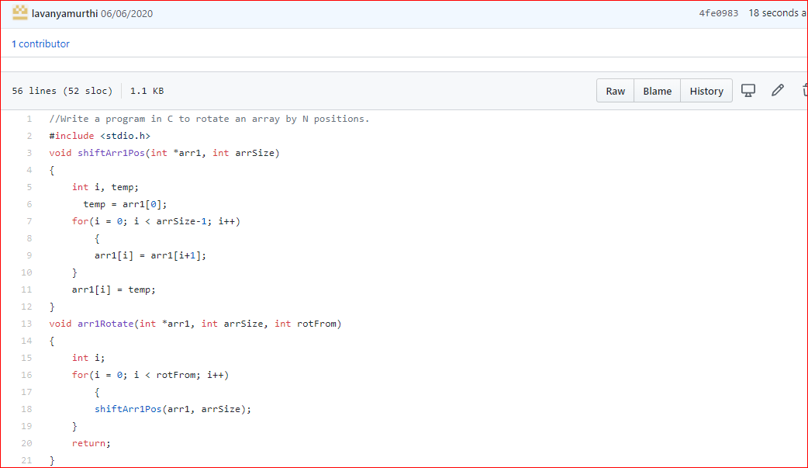

Problem 2: Write a Java Program to find the second-highest number in an array.

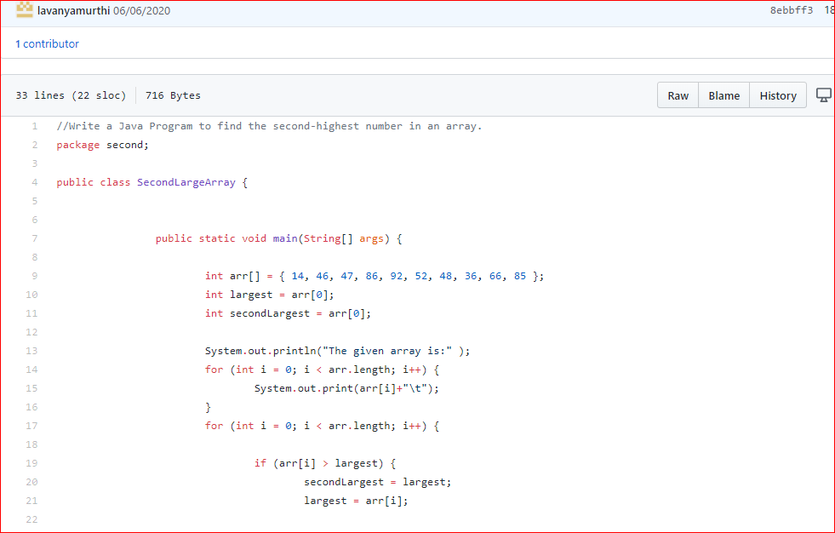

Problem 3 : Given an array A of size N containing 0s, 1s, and 2s; you need to sort the array in ascending order.  
Input:  
The first line contains an integer 'T' denoting the total number of test cases. Then T testcases follow. Each testcases contains two lines of input. The first line denotes the size of the array N. The second lines contains the elements of the array A separated by spaces.

Output:  
For each testcase, print the sorted array.

Constraints:  
1 <= T <= 500  
1 <= N <= 106  
0 <= Ai <= 2

Example:  
Input :  
2  
5  
0 2 1 2 0  
3  
0 1 0

Output:  
0 0 1 2 2  
0 0 1

